Onsite Work order

1)create a case , click on the onsite work order

Fill mandatory fields and click on the save button.

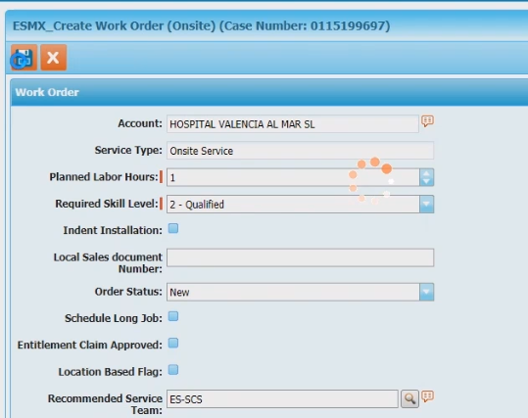

2)Click on the “Initiate SWO”

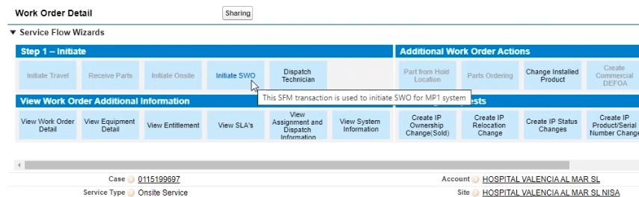

Verify SWO created as show below

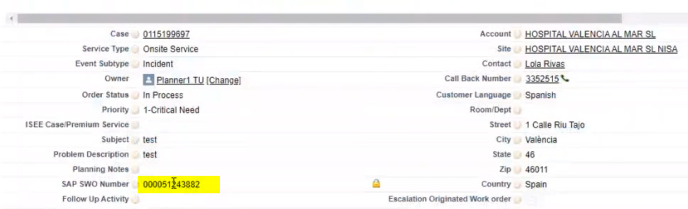

3)Click on the dispatch technician.

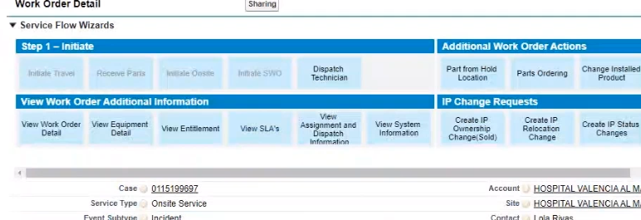

Dispatch the WO to technician.

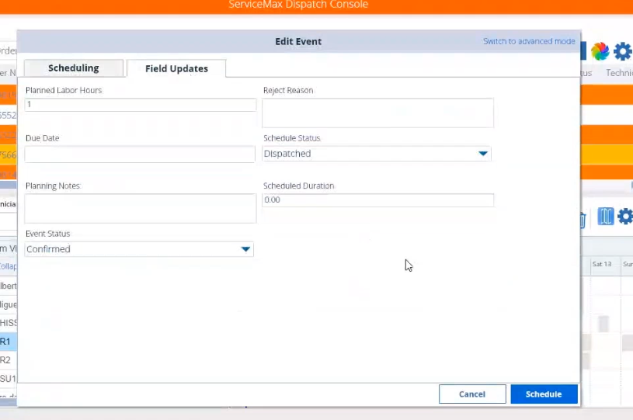

Change schedule status to “Dispatched” and Event status as Confirmed and Click on

Schedule.

4)Login as Service user

Open the work order.

5)Click on “Initiate Travel”

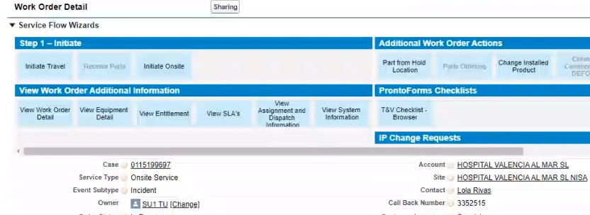

6)Click on “Initiate Onsite”

7)Click on the “Add labor or parts”

Click on the Open Labor ,

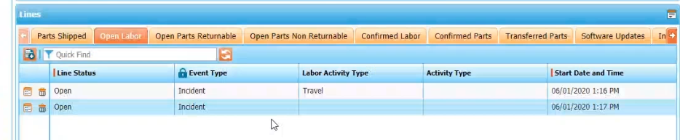

8)Edit 1st row as ,

Line status = Confirmed and Labor Activity type as “Travel”

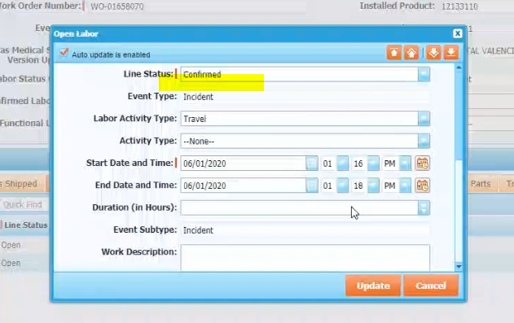

Second row as shown below, 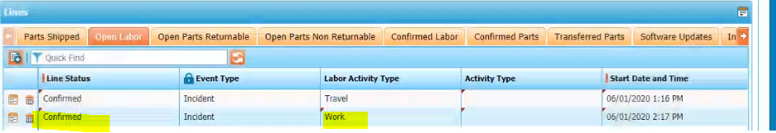

9)Post that we can click on Save

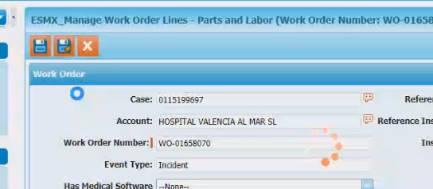

10)Click on debrief & Follow up

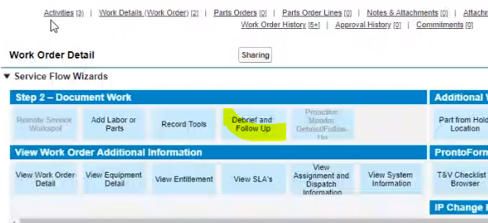

11)Fill the mandatory fields

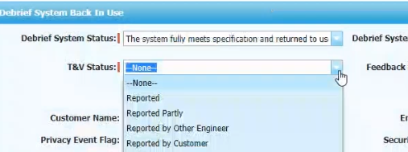

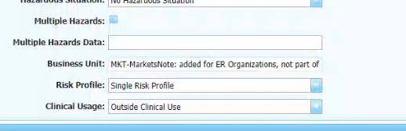

Update below row

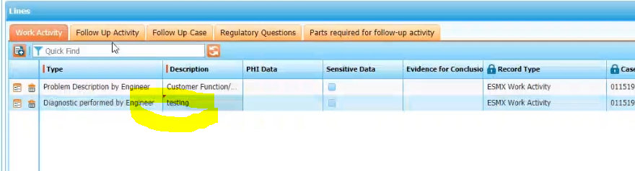

Note:-

If the work order is completed fully then , we have to create the a follow up work order by filling below details ,under the “Follow up Activity”

Click on the add row button and choose service type



11)Fill the regulatory questions

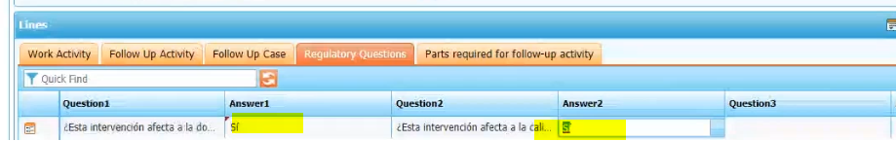

Click on save button.

Status of the work order will change to fix status after the batch job run.